SELF-IDENTIFICATION “EVERYDAY HYGIENE”: ASSAGIOLI
Aligning the Translations of Assagioli’s Manual

Isabelle Clotilde Küng

rom 1964 to 1981 I taught self-formative psychosynthesis to young adults at my mother’s private school in Switzerland, which my husband and I eventually directed. After closing the school, I occasionally gave these
F
courses to private persons on request.

I based my teaching on what Assagioli had told me during my didactic training and the lessons and talks he gave in Florence over the years. Additionally, I had always relied for reference on the first English version of Psychosynthesis: A Manual of Principles and Techniques (1965).1 Assagioli had given this book to me and my husband as a wedding present in March 1966. Earlier, he had already shared the mimeographed preprint version. I therefore did not even think of looking through the Italian and French versions of Assagioli’s Manual when they came out in 1973 by Astrolabio in Rome and in 1976 by L’Epi in Paris, respectively. I assumed that they were
identical (synchronized). But it turns out they were not! How did I find out? Well, it was like a slap in the face!
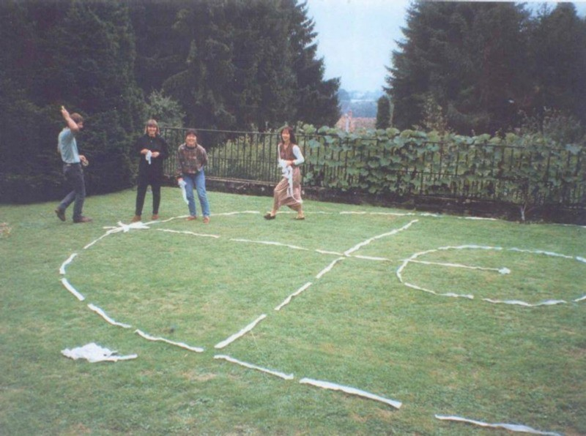

From 1994 to 1996 I was happily giving a self- formative Psychosynthesis class to a small group of adults (at left, a photo in the garden 1996). A woman named Danielle (in jeans in the picture) had asked me to give the course. She was also training in Jungian Analytic Psychology and fre- quenting the Paris Psychosynthesis Centre. She said, “We have a problem with the exercise of identification with the transpersonal Self; would you please facilitate it again?”. Of course I was more than willing to do so, and we sat on the carpet of an all-wooden cozy chimney room and went through the Self-identification experience.

Ten to fifteen minutes later we took a break, and after a refreshing drink that brought us all back to earth, here comes Danielle. She looks at me and says, in a shy and yet assertive tone of voice, backed by the silent approbation of the other participants, “But Isabelle . . . [deep breath] . . . you are teaching something other than what is written in Assagioli’s book!”

That’s what felt like a “slap!” I thought I had not heard well. What! Me? What are they referring to? So I asked them, “Which book?” And they showed me the French version of Assagioli’s Manual of Psychosynthesis, which I used to recommend to French-speaking persons. And they added: “You see, you talk about identification with the Self first, but that is not how the exercise of disidentification is presented. In the book it begins with the exercise of disidentification, and only then culminates with the formula of identification with the transpersonal Self, and that’s it; whereas you—you begin with identification with the transpersonal Self, and after that you transmit the four stages of that exercise: after you present the three stages of disidentification, at the fourth stage you again affirm our identity with transpersonal Self.”

The least you can say is that they had been most attentive learners: it takes quite a bit of reflection and “thinking through” to reach to the point they raised. And that point happens to be most important. And they were right, because the many techniques that are appropriate to practice in the psychosynthetic approach are incidental to the therapy or self-actualization process. These can be borrowed from various sources, such as psychoanalysis, gestalt, transactional analysis, or sophrology, as long as they are put in practice from a psychosynthetic, and therefore detached, relative, timely, harmless, responsible and non-dogmatic point of view.

So this gave me the opportunity to deepen the subject with them. And thanks to them, I discovered that the Italian and French versions of Assagioli’s book were not synchronized with
the English version.
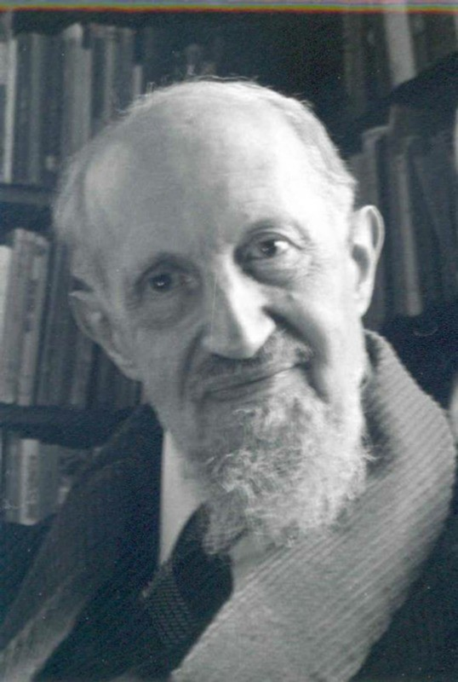

As soon as the group left, I plunged into my French version of the book and compared it to the English version I had received from Assagioli. . . Yes, indeed, only in the English version do you find this main title Self-Identification, beginning at page 111 (page 98 of the Synthesis Center edition of 2000—Ed.), followed by the subtitles purpose, rationale, until page 114; and then from page 114 to page 116 followed by procedure. In the Italian and French, the discussion jumps, after the Critical Analysis technique, directly to Exercise in Dis-identification and Self-Identification and the exercise proper, which in the English goes from the bottom of page 116 to the top of page 119. The Italian and French versions skip the fundamental complementary information given at page 120 of the English edition (page 106 in the 2000 edition—Ed.). So there is a paragraph that is missing in the Italian and French versions. It is so useful and of such practical value that I wish to quote it in full:

As the technique of self-identification is a basic technique not only for therapy but for education and personality integration, it can be considered also as a defense mechanism against the constant stream of influences, inner and outer, which try to capture the ego and demand identification. This technique can also be considered as a matter of everyday psychological and

Roberto Assagioli in Florence, 1969 Photo by the author

spiritual hygiene, and in therapy it is needed even more. Therefore, we advise the patient to use it as frequently as he feels is possible; once a day is sufficient, but that is a minimum. As mentioned above, it should precede the use of the other techniques because it helps the patient to use them more effectively.2

And then the English version from page 120 to 125 discusses additional material that is missing in the Italian and French versions: Indications and Applications, then Limitations and Contra-Indications, then Borderline Cases and Psychotics, and finally Summation and Combination with other Techniques.

From there on, the Italian and French and English versions are again synchronized, continuing with the topic of the Will. Here Assagioli limits himself to a short description of the Techniques for the Development of the Will. These sections he will completely recreate and develop into his last book, The Act of Will, published in 1973.

And indeed, The Act of Will somehow bridges the differences between the versions of the Manual. In Appendix One, on page 213, under the title Disidentification and Self-Identification, Assagioli includes the discussion on

the advantages of identification with the Transpersonal Self. There he presents pretty much the same consider- ations as those already mentioned in the English version of the Manual (but skipped in the Italian and French versions), along with a few enriching variations. So all is well, and I think one could even say that both explanations (in The Act of Will and in the English version of the Manual) warrant being studied.

Here are the main points, worth paying attention to. They aptly motivate one to practice this exercise and thereby benefit from its lasting effects. Note that the whole passage of page 213 in The Act of Will, on the Disidentification and Self-identification exercise, is worth reading. Here I only copy for you those excerpts that, read in a flow as given below, shed a light on the need to practice this exercise, as advised in the Manual (page 120)—possibly daily, as a psychological hygiene practice. By analogy, we need to turn on the motor before driving the car! When introducing the topic of the Will, Assagioli liked to point out with a sly grin, “Instead of attempting to push the car from outside, with its brakes still on, wouldn’t it be easier to just sit in the driver’s seat, insert the key, and turn on the power? And then drive—that is, learn to drive.” This pinpoints the problematic nature of our will and motivates one to discover how it works and to learn to use it effectively. And then he would often add, “You would be astonished to see how many people actually stick to pushing the car from outside rather than driving it from the driver’s seat! Inside.”

Here are excerpts to motivate one to do both the exercise for disidentification and for Self-Identification, and to discover the reality of our main function, the will:

If a continuing identification with either a role or a predominant function leads often, and almost inevitably, to a precarious life situation resulting sooner or later in a sense of loss, even despair . .
. no frantic clinging to the waning old “identity” can avail. The true solution can only be a “rebirth,” that is, entering into a new and broader identification. This sometimes involves the whole personality and requires and leads to an awakening or “birth” into a new and higher state of being. . . . This process often occurs without a clear understanding of its meaning and often against the wish and will of the individual involved in it. But a conscious, purposeful, willing cooperation can greatly facilitate, foster, and hasten it. It can be best done by a deliberate exercise of disidentification and self-identification. . . . Thus we can learn to master, direct and utilize all the elements and aspects of our personality, in an inclusive and harmonious synthesis. Therefore this exercise is considered as basic in psychosynthesis.3

As to my story above, where I described how my students put me right, as soon as they left I also ordered Assagioli’s first Manual in Italian, to check whether it is like the English or like the French. I was a little afraid the French one would be the only one to differ. When I received the Italian Manual, I double checked to find that the French and Italian were identical as regards what was missing. And I noticed that some short passages were in the French and Italian but not in the English. What had happened? Why was the core, the very heart of Assagioli’s psychosynthesis, missing in the Italian and French versions?

I would say it was just coincidence, circumstances, chance!

You see, the first Italian version, translated by Elena Zanotti from the English, was published by Astrolabio in Rome in 1973. Assagioli was then completely absorbed in the writing and publication of The Act of Will. He knew he had little time left (that will be the subject of another article), so he probably did not feel like correcting the matter. The new book was more important. But there is an indication that he had noticed. I visited him for three days in July 1974 to invite him to sign the founding act of the educational psychosynthesis center at my school, and he gave me a bundle that had been packed up the day I left, July 14. He said, “please send this to Paris, it is better they have this version for the Manual they offered to publish.” Returning by the night train, I was robbed!

No, not the bundle, just my handbag with ticket, passport, money. But would you believe it . . . bad luck was again watching. I sent that bundle, but it too was lost, probably because of the postal strike! Oh, how I regret not having sent it immediately. Neverthe- less, in 1976, two years after Assagioli had passed away, the French version was published—translated into French by Maria Panizza (photo) from that Italian translation Elena Zanotti had done from the English for the 1973 first publication in Italian. (Do you follow me here? Apparently the bundle I sent, which was lost, contained Assagioli's corrections to the Italian version. So the French version was based on an uncorrected Italian version.) That French version was the very book which my French-speaking students had told me about!

As a corollary, here is a personal viewpoint, based on my experience teaching psychosynthesis to young adults, and practicing it volens nolens for myself: the rather technical explanation which is the object of this article happened to bring to the fore in a quite obvious way the reason why the transpersonal Self, in a necessarily limited two-dimensional egg-shaped diagram of the psychological constitu- tion of the human being, is depicted as it is. The symbol of the transpersonal Self, the Shining Sun, is placed indicatively at the top of the “egg,” and precisely half in, half out of it, because the transpersonal Self is that Reality which we are energetically. That


Maria Panizza, translator of Assagioli’s articles Capolona, Italy 1963

is the reason it is relatively invisible and so needs to be represented by a symbol. It—yes, the transpersonal Self—bridges us with our everyday field of work. It mirrors itself in our personality, with its tools—the psychological functions. (Might we call them the human soul, given that Assagioli chose to represent them by a star?) Rereading the excerpts of Assagioli’s explanations will make this crystal clear! When I say that this Sun symbolizes the transpersonal Self, I mean that it hints at the threshold to that which confers dignity to human life. The symbol it represents is that of the soul. Without it we may jolly well be well-groomed humans, but without purpose we are readily tossed by adverse blows . . . like “puppets on a string” commanded by the will of others, whoever they be.

A “belated birthday present” for Assagioli.

My gift is simply the “restoring” or bringing back to public visibility or calling back into the present, one basic principle. He gave his whole life to bring this principle to public recognition: that the realization of the transpersonal Self is the heart of the psychosynthetic approach or attitude toward existence. That is what empowers the practice of the many techniques and exercises fostering self-realization, and warrants integrating them into the art of daily living “in perfect harmony.” Furthermore, as he observed during his lifelong practice as a psychiatrist, the transpersonal Self is an experience that can be induced. He represented it by the Shining Sun icon, a reminder of the “elevating” effect the transpersonal Self exercises on the personal areas of the often problematic “horizontal expression.” It is obvious that this is why the place of this icon is at the top of the egg-shaped diagram of the psychological constitution. (This is symbolic, of course, just as the whole diagram is only a static symbol standing for a dynamic, ever-moving psychic “metabolism.”) Also, the fact that Assagioli placed the Shining Sun symbol of the transpersonal Self half in and half out of the field of the personal ego indicates that the domain of psychosynthesis is personal-ego harmonization and development as well as harmo- nization of the contents of the higher unconscious, which latter he called spiritual psychosynthesis. (See Manual
p. 166 as to why he names the personality “ego,” as quoted below, at the end.)

By fostering the realization of the transpersonal Self, psychosynthesis leads to the threshold of higher conscious- ness, and stops there. Assagioli recognized, as he mentions in the French (p. 37) and Italian (p. 32) versions of his article Dynamic Psychology and Psychosynthesis, that there is “a spiritual Reality beyond and above the transpersonal Self.” He did not wish to discuss it there (at the personal-and spiritual-psychosynthesis level), given that it raises questions of a “meta-psychological” dimension. He himself had a vast and far-reaching comprehen- sion of the “inner worlds” and wrote courses for development on those levels. However, he considered it of paramount importance that students in those subjects be able to master harmlessly the high voltages that awareness of the inner dimension unlocks. (It is comparable, but not identical, to the harnessing of nuclear energy.) He felt that they first ought to harmonize their personality and be able to master the personal forces. He wanted them to have conquered or “remembered” (symbolically speaking) consciousness in the transpersonal Self, and realized it harmlessly; that is, be able to work it out also in daily-life circumstances.

If my anecdote about the lack of synchronization between the various language versions of Assagioli’s Manual made these points clear, it illustrates how a “problem” may have constructive and useful effects—and make the belated birthday “present” to him also one for us.

In a statement from one of the many poetic, heartfelt, mystical dreams that he shared, Assagioli gave a synthesis of this work of his, which is potentially every human’s task on various levels of Reality. He cultivated these levels without mixing and confusing them. Here it is. It speaks equally to the simple beginner in the work of self-actualization, and someone striving to realize his transpersonal Self—as well as the most advanced and learned human being: “May the wave of new life descend from the Supreme Being of our planet, and pervade
our daily existence.”

Parc Bertrand, Geneva - Photo by the author

That says it all. In other terms one could say: let us connect to our transpersonal Self (our true Self) and thus perceive the regenerating power of the Infinite which throbs in our heart. Let us make appropriate use of this power within the sphere of our responsibilities: our little kingdom which we must defend with the radiation of this energy of the Self. It is also alive in every atom of our body! If you remember your anatomy classes, your physics and chemistry lessons, and the general science topics you studied, you will feel that connection with yourself as Self, as well between you as Self and yourself. . . For consciousness is the key, and it is in your hands.

For let us admit it: even if we live with our feet on earth—and we had better do so indeed—we however cannot, today and as educated beings, ignore that the universe is infinitely vast. Its laws, by which life on this planet can unfold, are the embodiment of an infinite intelligence. Or as Dante poetically illustrated it in his Divine Comedy: “Luce intellectual piena d’Amor”—Intellectual Light substantiated by Love. We are a spark of that. That energy is all there is, so we too are energy. We have the opportunity to act through our personalities. It behooves us to measure up to this huge opportunity by urgently willing to learn to use this energy in a benign manner and integrate it into our everyday realities. It is up to us. Knowing how to handle these energies protects us from being dominated by who knows what. It is for this that Roberto Assagioli worked.

To end, a quote from Roberto Assagioli's Manual of Principles and Techniques, page 166 (page 147 in the 2000 edition—Ed.): “We must become aware that each of us has within himself various self-models or models of the ego, or—more exactly, using our terminology—of the personality” (my emphasis). ◙

Notes:

1 Hobbs Dorman & Company, Inc. New York


2 Page 120, R. Assagioli (1965) English edition
3 The Act of Will page 213.

Isabelle Clotilde Küng was trained from 1963 to 1974 by Roberto Assagioli to teach Psychosynthesis to the students of Institut Bleu-Léman in Villeneuve, Switzerland. After closing her school, Isabelle worked in international corporations and now writes about her experiences as a pioneer in teaching Psychosynthesis, both as a subject matter and simply as an “Attitude that matters”.

Source: AAP Psychosynthesis Quarterly – June 2018

